

**Trimester: I/II/III Subject: Programming and Problem Solving**

**Name**: Krishnaraj Thadesar **Division:** 9

**Roll No.:** 109054 **Batch:** I3

**Experiment No.:** 5

**Name of the Experiment:** Write a Menu driven C program to perform all String operations using User Defined functions.

**Performed on:** 3rd February 2022

**Submitted on:** 21st January 2022

**AIM**: Write a Menu driven C program to perform all String operations using User Defined functions.

**OBJECTIVE:**

1. To learn and understand arrays in C.
2. To learn and understand two dimensional arrays and operation on it.

**THEORY:**

*What is an Array?*

An Array is a collection of similar type of data items stored at contiguous memory locations. It is a variable that can store multiple values.

*Types of Arrays:*

1. *One Dimensional Array:*

In C programming language, one dimensional arrays are used tos teore a list of values of the same data type.

Eg. Int marks[2] = {99, 98};

1. *Two Dimensional Array*: An array having more than one dimensions is known as a multi-dimensional array. If the array has 2 dimensions, it is known as a two dimensional array.

Eg. int matrix[2][2] = {

{1, 2}

{2. 3}

}

1. *Multi-dimensional Arrays*: An array having more than one dimensions is known as a multi-dimensional array

*Declaration of a 1D Array*

1. The declaration must have a data type (int, char, float, double, etc), variable name, and square brackets with the number of elements of the array inside it.
2. Subscript or the square brackets represents the size of the array.
3. Array index always starts from 0
4. Each element in stored in a separate memory location.

*Declaration of a 2D Array*

Syntax: data_type array-name[row-size][col-size]

Initialization: int matrix[2][2] = {

{1, 2}

{2. 3}

}

# PLATFORM: *Windows 11 64 Bit*

# ALGORITHM:

Step 1: Start

Step 2: Declare 3 Matrices of Size [3][3] each and assign them to zero.

Step 3: Input the First Matrix

Step 4: Input the Second Matrix

Step 5: Write another nested For loop

Step 6: Switch the Choice variable inside the for loop

Step 7: If choice is 1, add the values, if choice is 2, subtract the values and assign them to the third matrix C.

Step 6: Output the Third Matrix

Step 7: End

# Flowchart:

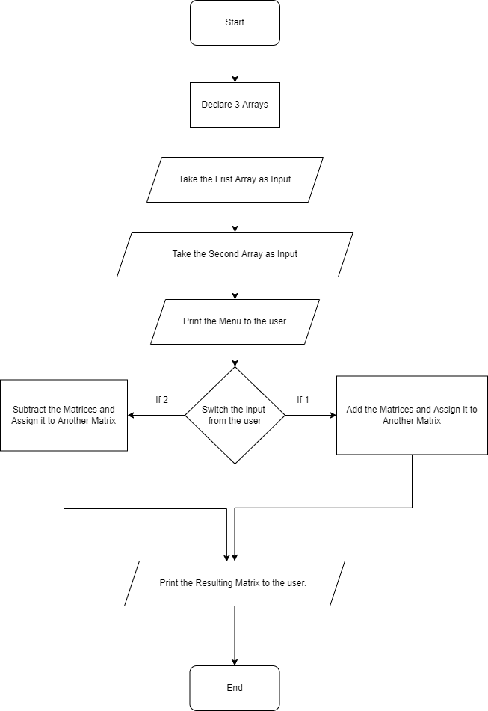

# CODE:

//     strlen() computes string's length strcpy() copies a string to another

//     strcat() concatenates(joins) two strings

//     strcmp() compares two strings

//     strlwr() converts string to lowercase

//     strupr() converts string to uppercase

// Write a menu driven program to perform all string operations (user defined functions)

#include <string.h>

#include <stdio.h>

#include <stdlib.h>

#include <math.h>

// User Defined Functions

int str_length(char *ptr)

{

    /*

        Function: Returns the number of characters in the given character.

        Input: char * pointing to the character array.

        Returns: Integer.

     */

    int count = 0;

    for (int i = 0; ptr[i] != '\0'; i++)

    {

        count++;

    }

    return count;

}

char *str_concat(char *user_string_1, char *user_string_2)

{

    /*

        Function: Returns a character pointer pointing to an array of characters that is made by concatenating 2 strings.

        Input: char * pointing to the 2 strings.

        Returns: char *.

     */

    // allocating on the heap coz otherwise it would be a local variable

    // that you cant pass outside the scope of this function as a pointer, as memory would be invalid.

    char *concat_string = malloc(1000);

    strcpy(concat_string, user_string_1);

    for (int i = 0; i <= str_length(user_string_2); i++)

    {

        concat_string[str_length(user_string_1) + i] = user_string_2[i];

    }

    return concat_string;

}

int str_compare(char *user_string_1, char *user_string_2)

{

    /*

        Compares the C string str1 to the C string str2.

        This function starts comparing the first character of each string.

        If they are equal to each other, it continues with the following pairs until the characters

        differ or until a terminating null-character is reached.

        Returns:

        <0  the first character that does not match has a lower value in ptr1 than in ptr2

        0   the contents of both strings are equal

        >0  the first character that does not match has a greater value in ptr1 than in ptr2

    */

    int result = 0;

    for (int i = 0; user_string_1[i] != '\0' || user_string_2[i] != '\0'; i++)

    {

        if (user_string_1[i] == user_string_2[i])

        {

            if (user_string_1[i + 1] == '\0' && user_string_2[i + 1] != '\0')

            {

                result = 0;

                continue;

            }

            else if (user_string_1[i + 1] == '\0' && user_string_2[i + 1] != '\0')

            {

                result = -1;

            }

            else if (user_string_1[i + 1] == '\0' && user_string_2[i + 1] == '\0')

            {

                result = 0;

            }

            if (user_string_1[i + 1] != '\0' && user_string_2[i + 1] == '\0')

            {

                result = 1;

            }

        }

        else if (user_string_1[i] < user_string_2[i] || user_string_1[i] > user_string_2[i])

        {

            result = (user_string_1[i] - user_string_2[i]) / abs(user_string_1[i] - user_string_2[i]);

            break;

        }

    }

}

char *str_lower(char *user_string)

{

    /*

    Returns a new char * to an array that contains the converted lowercase of the user_string

    */

    char *lower_string = malloc(1000);

    strcpy(lower_string, user_string);

    for (int i = 0; i < str_length(lower_string); i++)

    {

        if (lower_string[i] >= 'A' && lower_string[i] <= 'Z')

        {

            int AASCI_val = lower_string[i] + 32;

            lower_string[i] = AASCI_val;

        }

    }

    return lower_string;

}

char *str_upper(char *user_string)

{

    /*

    Returns a new char * to an array that contains the converted uppercase of the user_string

    */

    char *upper_string = malloc(1000);

    strcpy(upper_string, user_string);

    for (int i = 0; i < str_length(upper_string); i++)

    {

        if (upper_string[i] >= 'A' && upper_string[i] <= 'Z')

        {

            int AASCI_val = upper_string[i] - 32;

            upper_string[i] = AASCI_val;

        }

    }

    return upper_string;

}

char *str_reverse(char *user_string)

{

    /*

    Returns a new char * to an array that contains the reversed user_string

    */

    // allocating on the heap coz otherwise it would be a local variable

    // that you cant pass outside the scope of this function as a pointer, as memory would be invalid.

    char *rev_string = malloc(1000);

    strcpy(rev_string, user_string);

    for (int i = 0; i < str_length(user_string); i++)

    {

        rev_string[i] = user_string[str_length(user_string) - i - 1];

    }

    rev_string[str_length(user_string)] = '\0';

    return rev_string;

}

int main()

{

    int choice = 0;

    char user_string[500];

    char user_string_1[500], user_string_2[500];

    printf("Enter What operation you want to perform [1, 2, 3, 4, 5]: \n\

        1. Find the length of the String\n\

        2. Concatenate 2 Strings\n\

        3. Compare 2 Strings\n\

        4. Convert a String to lowercase\n\

        5. Convert a String to Uppercase\n\

        6. Reverse a string\n\

        ");

    scanf("%d", &choice);

    switch (choice)

    {

    case 1:

        printf("Enter the String that you want to find the length of: ");

        scanf("%s", &user_string);

        printf("The Length is: %d", str_length(user_string));

        break;

    case 2:

        printf("Enter the First String: ");

        scanf("%s", &user_string_1);

        printf("Enter the First String: ");

        scanf("%s", &user_string_2);

        printf("The Concatenated is: %s", str_concat(user_string_1, user_string_2));

        break;

    case 3:

        printf("Enter the First String: ");

        scanf("%s", &user_string_1);

        printf("Enter the First String: ");

        scanf("%s", &user_string_2);

        printf("The Comparison of the Strings is: %d", str_compare(user_string_1, user_string_2));

        break;

    case 4:

        printf("Enter the String that you want to convert to lowercase to: ");

        scanf("%s", &user_string);

        printf("The converted String is: %s", str_lower(user_string));

        break;

    case 5:

        printf("Enter the String that you want to convert to Uppercase to: ");

        scanf("%s", &user_string);

        printf("The converted String is: %s", str_upper(user_string));

        break;

    case 6:

        printf("Enter the String that you want to reverse: ");

        scanf("%s", &user_string);

        printf("The converted String is: %s", str_reverse(user_string));

        break;

    default:

        printf("Incorrect Choice, Please try again.");

    }

    return 0;

}

**OUTPUT**

What operation you want to perform [1, 2, 3, 4, 5]:

        1. Find the length of the String

        2. Concatenate 2 Strings

        3. Compare 2 Strings

        4. Convert a String to lowercase

        5. Convert a String to Uppercase

        6. Reverse a string

        1

Enter the String that you want to find the length of: example

The Length is: 7

2

Enter the First String: example

Enter the First String: String

The Concatenated is: exampleString

3

Enter the First String: First

Enter the First String: Second

The Comparison of the Strings is: -1

3

Enter the First String: First

Enter the First String: First

The Comparison of the Strings is: 0

4

Enter the String that you want to convert to lowercase to: LOWERcase

The converted String is: lowercase

5

Enter the String that you want to convert to Uppercase to: upperCASE

The converted String is: UPPERCASE

6

Enter the String that you want to reverse: reverse

The converted String is: esrever

**CONCLUSION:**

The working, concept and implementation of single and multi-dimensional arrays was understood in detail and implemented using switch case in a menu driven program.

**FAQs:**

*Q1. What are the different types of arrays and how do we define them?*

Ans. There are 2 Types of arrays:

1. *One dimensional arrays*
2. *Two dimensional Arrays*

*One Dimensional Arrays:*

They are arrays that have a single subscript.

Syntax: data_type array-name[size]

Multi-dimensional Arrays:

An array having more than one dimensions is known as a multi-dimensional array.

Syntax: data_type array-name[row-size][col-size]

*Q2. How are arrays initialized and processed?*

Ans. Initialization (static):

int matrix[2][2] = {

{1, 2}

{2. 3}

}

Initialization (dynamic):

int matrix[2];

matrix[0] = 1;

matrix[1] = 2;

*Q3. How are elements accessed in a 2D array?*

Elements in a 2-dimensional array are accessed using row and column indices.

For eg.

M = {{1, 2}

{2, 3}}

M[0][1] = 2;

This shows that the element in the 1nd row and 2nd column is 2.